# IBM Data Analytics

# Assignment-2

# Batchu Ramya

# 21BCE9106

# VIT-AP

**Now the data set that we have used in the HRDataset_v14.csv this is the name modification for the data set is deleting the Emp id this is the unimportant row and after that create the Dashboard, Report, Story This is the real shown in the Excel sheet**

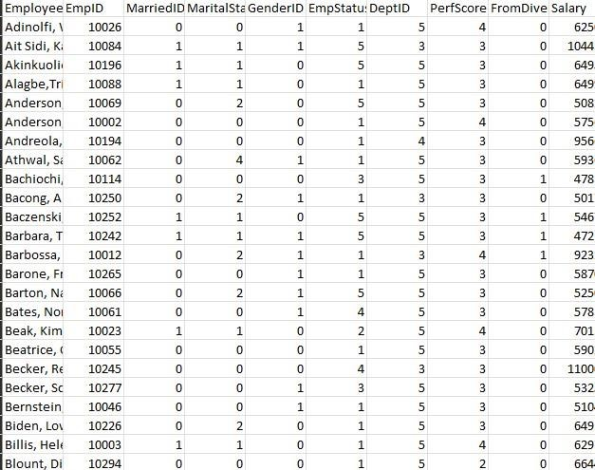

**Modified data:**

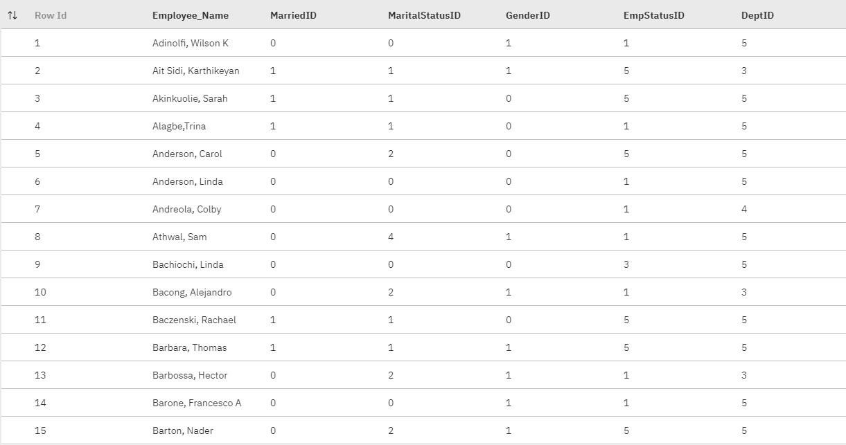

**Now the Dashboard pics**

# 1. This Dashboard contain all boxed visualizations

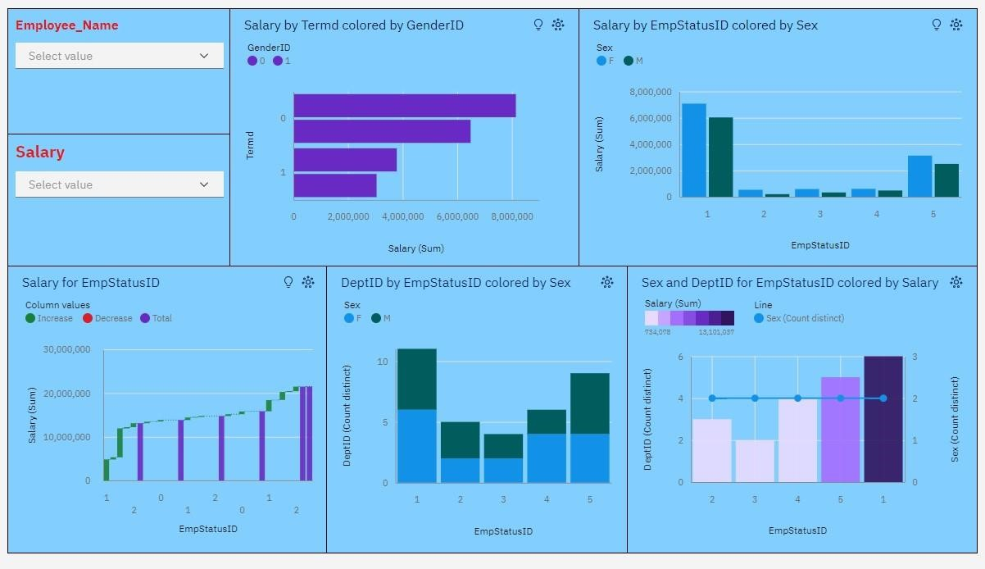

# 2. This Dashboard contain all Circular visualizations

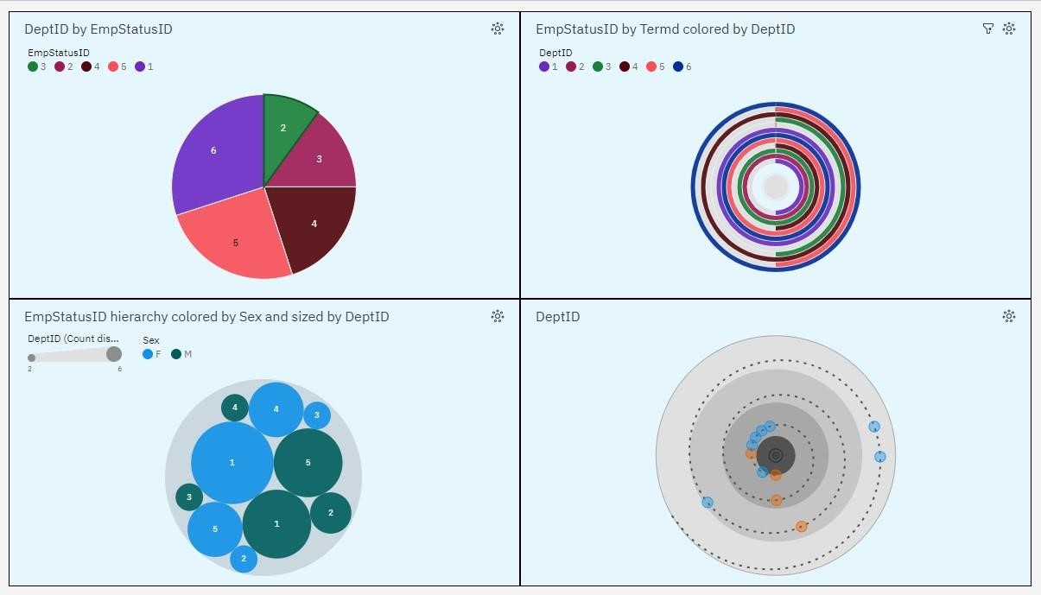

# 3. This Dashboard Contain all the no shaped visualizations

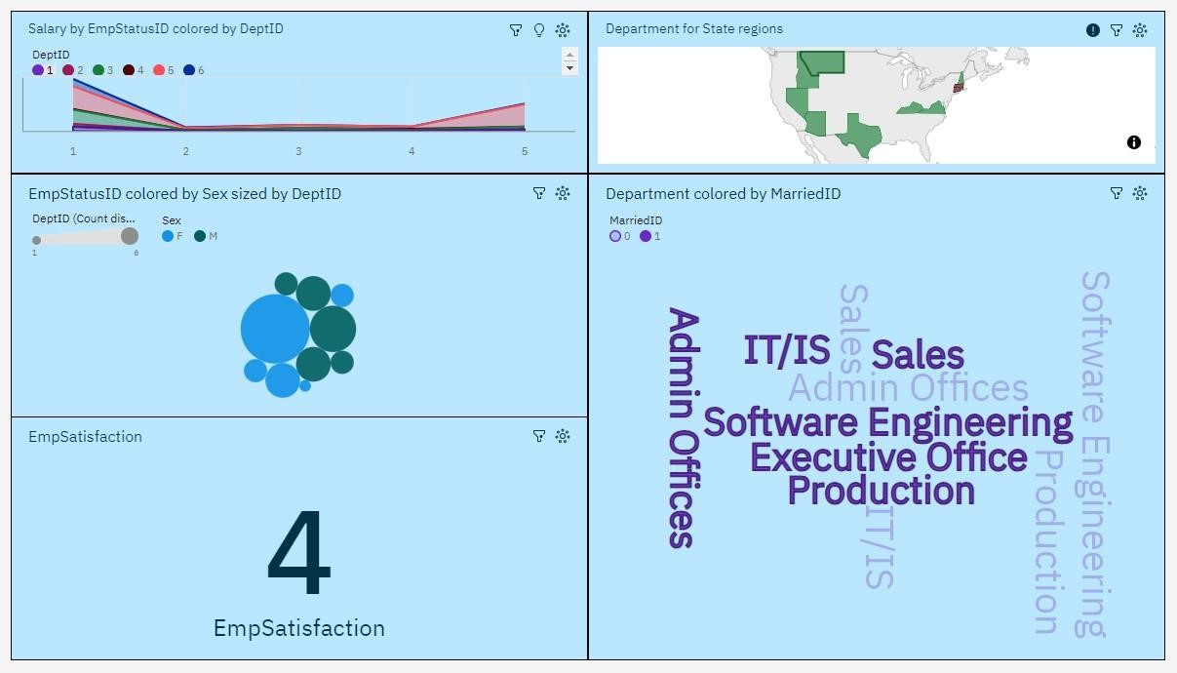

# Now See the Reports for the Data module 1. This Report contain all Circular visualizations

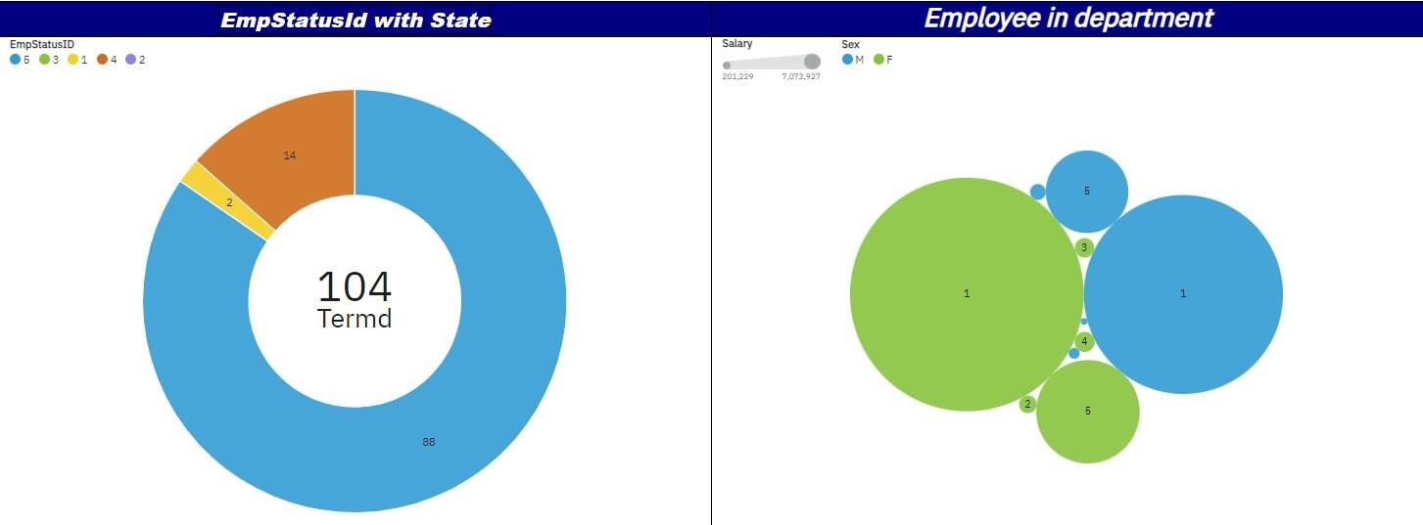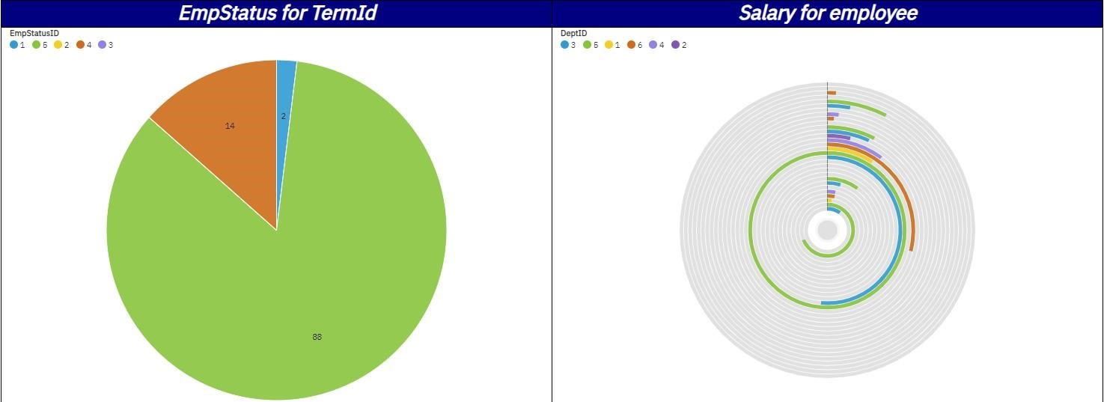

# 2. This Dashboard contain all boxed visualizations

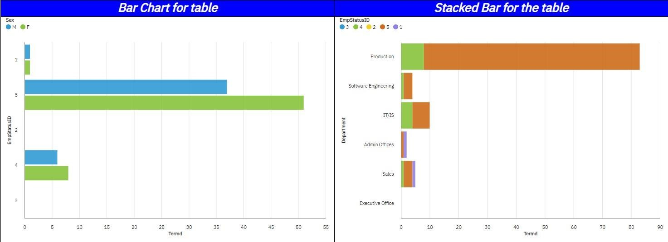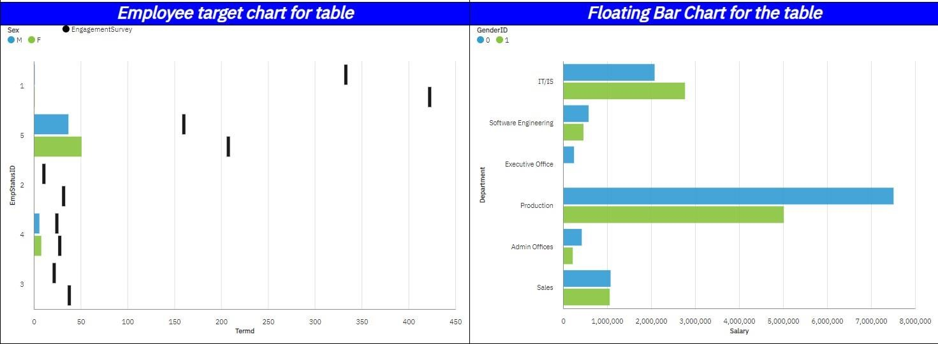

# 3. This Report contain no shape just 2

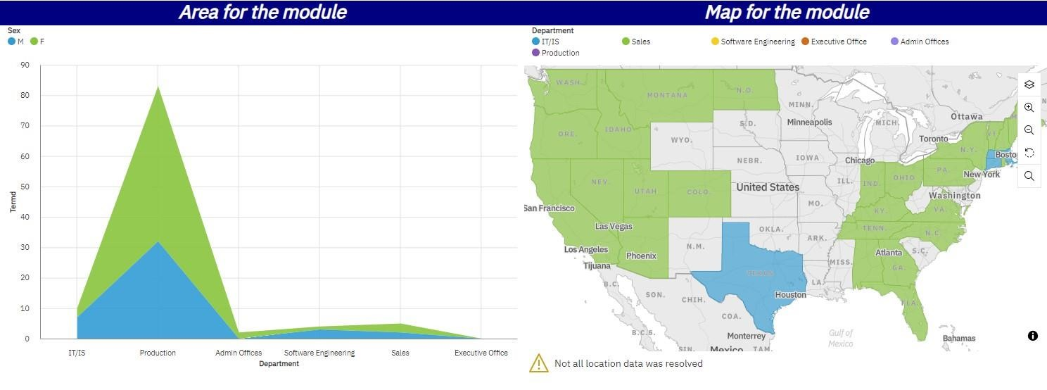

**Now the Stories**

# Story 1

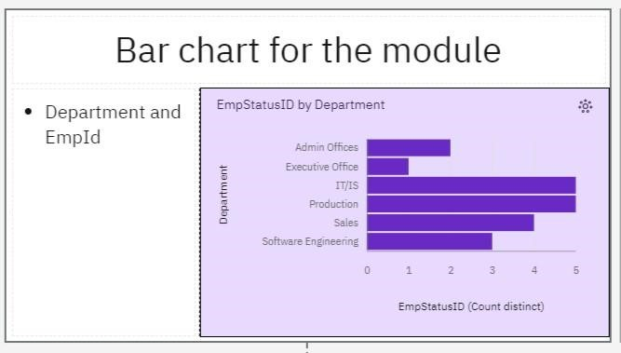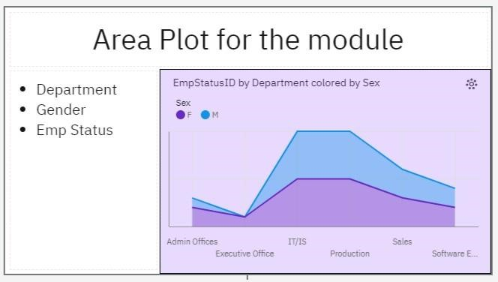

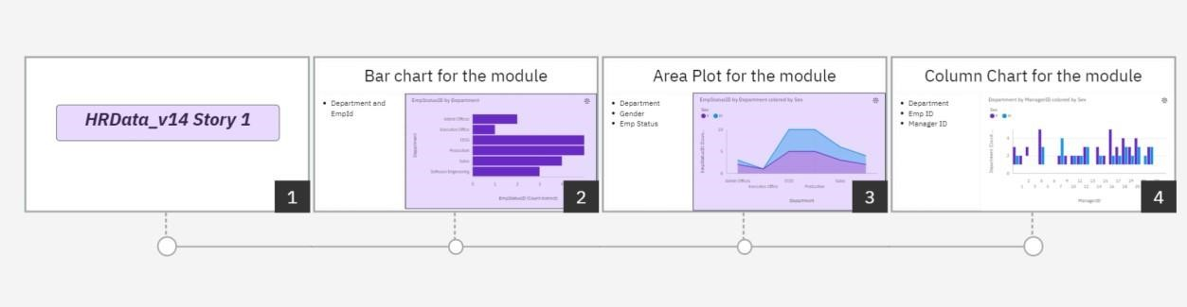

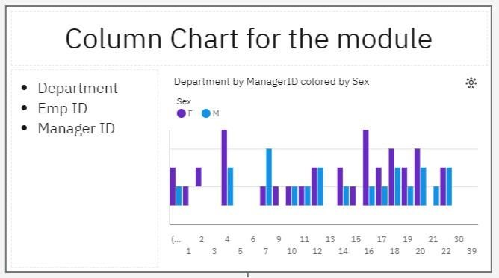

# Story 2

